

КАТАЛОГ КУХОННЫХ ФАРТУКОВ (СКИНАЛИ)

1 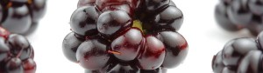2 3

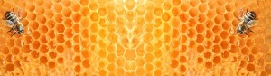4 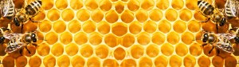5 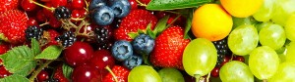6

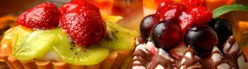7 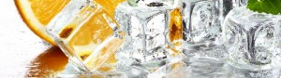8 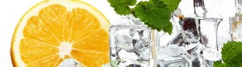9

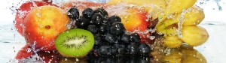10 11 12

13 14 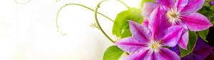15

16 17 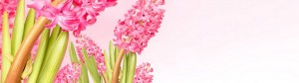18

19 20 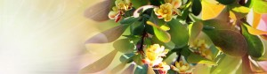21

22 23 24

25 26 27

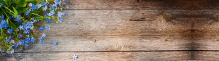28 29 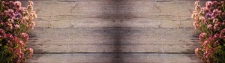30

31 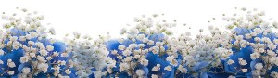32 33

34 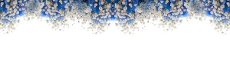35 36

37 38 39

40 41 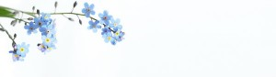42

43 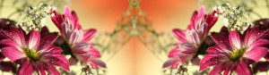44 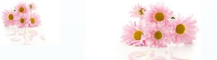45

46 47 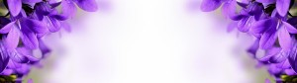48

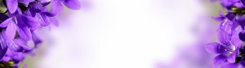49 50 51

52 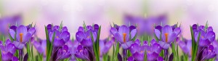53 54

55 56 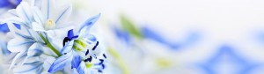57

58 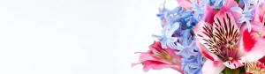59 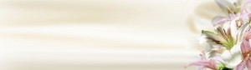60

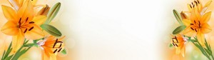61 62 63

64 65 66

67 68 69

70 71 72

73 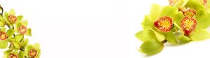74 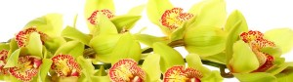75

76 77 78

79 80 81

82 skinalli8383 skinalli8484

skinalli8585 skinalli8686 skinalli8787

skinalli8888 skinalli8989 skinalli9090

skinalli9191 92 skinalli9393

skinalli9494 skinalli9595 96

skinalli9797 98 99

skinalli100100 101 skinalli102102

skinalli105103 skinalli104104 skinalli105105

skinalli106106 skinalli107107 skinalli108108

skinalli109109 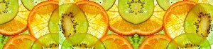110 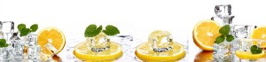111

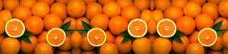112 113 114

# skinalli115115 skinalli116116 skinalli117117skinalli118118 skinalli119119 skinalli120120skinalli121121 skinalli122122 skinalli123123skinalli124124 skinalli125125 skinalli126126skinalli127127 skinalli128128 skinalli129129skinalli130130 skinalli131131 skinalli132132skinalli133133 skinalli134134 skinalli135135skinalli136136 skinalli137137 skinalli138138skinalli139139 skinalli140140 skinalli141141skinalli142142 skinalli143143 skinalli144144skinalli145145 skinalli146146 skinalli147147skinalli148148 skinalli149149 skinalli150150skinalli151151 skinalli152152 skinalli153153skinalli154154 skinalli155155 skinalli156156skinalli157157 skinalli158158 skinalli159159skinalli160160 skinalli161161 skinalli162162skinalli163163 skinalli164164 skinalli165165skinalli166166 skinalli167167 skinalli168168skinalli169169 skinalli170170 skinalli171171skinalli172172 skinalli173173 skinalli174174skinalli175175 skinalli176176 skinalli177177skinalli178178 skinalli179179 skinalli180180skinalli181181 skinalli182182 skinalli183183skinalli184184 skinalli185185 skinalli186186skinalli187187 skinalli188188 skinalli189189skinalli190190 skinalli191191 skinalli192192skinalli193193 skinalli194194 skinalli195195skinalli196196 skinalli197197 skinalli198198skinalli199199 skinalli200200 skinalli201201skinalli202202 skinalli203203 skinalli204204skinalli205205 skinalli206206 skinalli207207skinalli208208 skinalli209209 skinalli210210skinalli211211 skinalli212212 skinalli213213skinalli214214 skinalli215215 skinalli216216skinalli217217 skinalli218218 skinalli219219skinalli220220 skinalli221221 skinalli222222skinalli223223 skinalli224224 skinalli225225skinalli226226 skinalli227227 skinalli228228skinalli229229 skinalli230230 skinalli231231skinalli232232 skinalli233233 skinalli234234skinalli235235 skinalli236236 skinalli237237skinalli238238 skinalli239239 skinalli240240skinalli241241 skinalli242242 skinalli243243skinalli244244 skinalli245245 skinalli246246skinalli247247 skinalli248248 skinalli249249skinalli250250 skinalli251251 skinalli252252skinalli253253 skinalli254254 skinalli255255skinalli256256 skinalli257257 skinalli258258skinalli259259 skinalli260260 skinalli261261skinalli262262 skinalli263263 skinalli264264skinalli265265 skinalli266266 skinalli267267skinalli268268 skinalli269269 skinalli270270skinalli271271 skinalli272272 skinalli273273skinalli274274 skinalli275275 skinalli276276skinalli277277 skinalli278278 skinalli279279skinalli280280 skinalli281281 skinalli282282skinalli283283 skinalli284284 skinalli285285skinalli286286 skinalli287287 skinalli288288skinalli289289 skinalli290290 skinalli291291skinalli292292 skinalli293293 skinalli294294skinalli295295 skinalli296296 skinalli297297skinalli298298 skinalli299)299 skinalli300300skinalli301301 skinalli302302 skinalli303303skinalli304304 skinalli305305 skinalli306306skinalli307307 skinalli308308 skinalli309309skinalli310310 skinalli311311 skinalli312312skinalli313313 skinalli314314 skinalli315315skinalli316316 skinalli317317 skinalli318318skinalli319319 skinalli320320 skinalli321321skinalli322322 skinalli323323 skinalli324324skinalli325325 skinalli326326 skinalli327327skinalli328328 skinalli329329 skinalli330330skinalli331331 skinalli332332 skinalli333333skinalli334334 skinalli335335 skinalli336336skinalli337337 skinalli338338 skinalli339339skinalli340340 skinalli341341 skinalli342342skinalli343343 skinalli344344 skinalli345345skinalli346346 skinalli347347 skinalli348348skinalli349349 skinalli350350 skinalli351351skinalli352352 skinalli353353 skinalli354354skinalli355355 skinalli356356 skinalli357357skinalli358358 skinalli359359 skinalli360360skinalli361361 skinalli362362 skinalli363363skinalli364364 skinalli365365 skinalli366366skinalli367367 skinalli368368 skinalli369369skinalli370370 skinalli371371 skinalli372372skinalli373373 skinalli374374 skinalli375375skinalli376376 skinalli377377 skinalli378378skinalli379379 skinalli380380 skinalli381381skinalli382382 skinalli383383 skinalli384384skinalli385385 skinalli386386 skinalli387387skinalli388388 skinalli389389 skinalli390390skinalli391391 skinalli392392 skinalli393393skinalli394394 skinalli395395 skinalli396396skinalli397397 skinalli398398 skinalli399399skinalli400400 skinalli401401 skinalli402402skinalli403403 skinalli404404 skinalli405405skinalli406406 skinalli407407 skinalli408408skinalli409409 skinalli410410 skinalli411411skinalli412412 skinalli413413 skinalli414414skinalli415415 skinalli416416 skinalli417417skinalli418418 skinalli419419 skinalli420420skinalli421421 skinalli422422 skinalli423423skinalli424424 skinalli425425 skinalli426426skinalli427427 skinalli428428 skinalli429429skinalli430430 skinalli431431 skinalli432432skinalli433433 skinalli434434 skinalli435435skinalli436436 skinalli437437 skinalli438438skinalli439439 skinalli440440 skinalli441441skinalli442442 skinalli443443 skinalli444444skinalli445445 skinalli446446 skinalli447447skinalli448448 skinalli449449 skinalli450450skinalli451451 skinalli452452 skinalli453453skinalli454454 skinalli455455 skinalli456456skinalli457457 skinalli458458 skinalli459459skinalli460460 skinalli461461 skinalli462462skinalli463463 skinalli464464 skinalli465465skinalli466466 skinalli467467 skinalli468468skinalli469469 skinalli470470 skinalli471471skinalli472472 skinalli473473 skinalli474474skinalli475475 skinalli476476 skinalli477477skinalli478478 skinalli479479 skinalli480480skinalli481481 skinalli482482 skinalli483483skinalli484484 skinalli485485 skinalli486486skinalli487487 skinalli488488 skinalli489489skinalli490490 skinalli491491 skinalli492492skinalli493493 skinalli494494 skinalli495495skinalli496496 skinalli497497 skinalli498498skinalli499499 skinalli500500 skinalli501501skinalli502502 skinalli503503 skinalli504504skinalli505505 skinalli506506 skinalli507507skinalli508508 skinalli509509 skinalli510510skinalli511511 skinalli512512 skinalli513513skinalli514514 skinalli515515 skinalli516516skinalli517517 skinalli518518 skinalli519519skinalli520520 skinalli521521 skinalli522522skinalli523523 skinalli524524 skinalli525525skinalli526526 skinalli527527 skinalli528528skinalli529529 skinalli530530 skinalli531531skinalli532532 skinalli533533 skinalli534534skinalli535535 skinalli536536 skinalli537537skinalli538538 skinalli539539 skinalli540540skinalli541541 skinalli542542 skinalli543543skinalli544544 skinalli545545 skinalli546546skinalli547547 skinalli548548 skinalli549549skinalli550550 skinalli551551 skinalli552552skinalli553553 skinalli554554 skinalli555555skinalli556556 skinalli557557 skinalli558558skinalli559559 skinalli560560 skinalli561561skinalli562562 skinalli563563 skinalli564564skinalli565565 skinalli566566 skinalli567567skinalli568568 skinalli569569 skinalli570570skinalli571571 skinalli572572 skinalli573573skinalli574574 skinalli575575 skinalli576576skinalli577577 skinalli578578 skinalli579579skinalli580580 skinalli581581 skinalli582582skinalli583583 skinalli584584 skinalli585585skinalli586586 skinalli587587 skinalli588588skinalli589589 skinalli590590 skinalli591591skinalli592592 skinalli593593 skinalli594594skinalli595595 skinalli596596 skinalli597597skinalli598598 skinalli599599 skinalli600600skinalli601601 skinalli602602 skinalli603603skinalli604604 skinalli605605 skinalli606606skinalli607607 skinalli608608 skinalli609609skinalli610610 skinalli611611 skinalli612612skinalli613613 skinalli614614 skinalli615615skinalli616616 skinalli617617 skinalli618618skinalli619619 skinalli620620 skinalli621621skinalli622622 skinalli623623 skinalli624624skinalli625625 skinalli626626 skinalli627627skinalli628628 skinalli629629 skinalli630630skinalli631631 skinalli632632 skinalli633633skinalli634634 skinalli635635 skinalli636636skinalli637637 skinalli638638 skinalli639639skinalli640640 skinalli641641 skinalli642642skinalli643643 skinalli644644 skinalli645645skinalli646646 skinalli647647 skinalli648648skinalli649649 skinalli650650 skinalli651651skinalli652652 skinalli653653 skinalli654654skinalli655655 skinalli656656 skinalli657657skinalli658658 skinalli659659 skinalli660660skinalli661661 skinalli662662 skinalli663663skinalli664664 skinalli665665 skinalli666666skinalli667667 skinalli668668 skinalli669669skinalli670670 skinalli671671 skinalli672672skinalli673673 skinalli674674 skinalli675675skinalli676676 skinalli677677 skinalli678678skinalli679679 skinalli680680 skinalli681681skinalli682682 skinalli683683 skinalli684684skinalli685685 skinalli686686 skinalli687687skinalli688688 skinalli689689 skinalli690690skinalli691691 skinalli692692 skinalli693693skinalli694694 skinalli695695 skinalli696696skinalli697697 skinalli698698 skinalli699699skinalli700700 skinalli701701 skinalli702702skinalli703703 skinalli704704 skinalli705705skinalli706706 skinalli707707 skinalli708708skinalli709709 skinalli710710 skinalli711711skinalli712712 skinalli713713 skinalli714714skinalli715715 skinalli716716 skinalli717717skinalli718718 skinalli719719 skinalli720720skinalli721721 skinalli722722 skinalli723723skinalli724724 skinalli725725 skinalli726726skinalli727727 skinalli728728 skinalli729729skinalli730730 skinalli731731 skinalli732732skinalli733733 skinalli734734 skinalli735735skinalli736736 skinalli737737 skinalli738738skinalli739739 skinalli740740 skinalli741741skinalli742742 skinalli743743 skinalli744744skinalli745745 skinalli746746 skinalli747747skinalli748748 skinalli749749 skinalli750750skinalli751751 skinalli752752 skinalli753753skinalli756754 skinalli755755 skinalli756756skinalli757757 skinalli758758 skinalli759759skinalli760760 skinalli761761 skinalli762762skinalli763763 skinalli764764 skinalli765765skinalli766766 skinalli767767 skinalli768768skinalli769769 skinalli770770 skinalli771771skinalli772772 skinalli773773 skinalli774774skinalli775775 skinalli776776 skinalli777777skinalli778778 skinalli779779 skinalli780780skinalli781781 skinalli782782 skinalli783783skinalli784784 skinalli785785 skinalli789786skinalli787787 skinalli788788 skinalli789789skinalli790790 skinalli791791 skinalli792792skinalli793793 skinalli794794 skinalli795795skinalli796796 skinalli797797 skinalli798798skinalli799799 skinalli800800 skinalli801801skinalli802802 skinalli803803 skinalli804804skinalli805805 skinalli806806 skinalli807807skinalli808808 skinalli809809 skinalli810810skinalli811811 skinalli812812 skinalli813813skinalli814814 skinalli815815 skinalli816816skinalli817817 skinalli818818 skinalli819819skinalli820820 skinalli821821 skinalli822822skinalli823823 skinalli824824 skinalli825825skinalli826826 skinalli827827 skinalli828828skinalli829829 skinalli830830 skinalli831831skinalli832832 skinalli833833 skinalli834834skinalli835835 skinalli836836 skinalli837837skinalli838838 skinalli839839 skinalli840840skinalli841841 skinalli842842 skinalli843843skinalli844844 skinalli845845 skinalli846846skinalli847847 skinalli848848 skinalli849849skinalli850850 skinalli851851 skinalli852852skinalli853853 skinalli854854 skinalli855855skinalli856856 skinalli857857 skinalli858858skinalli859859 skinalli860860 skinalli861861skinalli862862 skinalli863863 skinalli864864skinalli865865 skinalli866866 skinalli867867skinalli868868 skinalli869869 skinalli870870skinalli871871 skinalli872872 skinalli873873skinalli874874 skinalli875875 skinalli876876skinalli877877 skinalli878878 skinalli879879skinalli880880 skinalli881881 skinalli882882skinalli883883 skinalli884884 skinalli885885skinalli886886 skinalli887887 skinalli888888skinalli889889 skinalli890890 skinalli891891skinalli892892 skinalli893893 skinalli894894skinalli895895 skinalli896896 skinalli897897skinalli898898 skinalli899899 skinalli900900skinalli901901 skinalli902902 skinalli903903skinalli904904 skinalli905905 skinalli906906skinalli907907 skinalli908908 skinalli909909skinalli910910 skinalli911911 skinalli912912skinalli913913 skinalli914914 skinalli915915skinalli916916 skinalli917917 skinalli918918skinalli919919 skinalli920920 skinalli921921skinalli922922 skinalli923923 skinalli924924skinalli925925 skinalli926926 skinalli927927skinalli928928 skinalli929929 skinalli930930skinalli931931 skinalli932932 skinalli933933skinalli934934 skinalli935935 skinalli936936skinalli937937 skinalli938938 skinalli939939skinalli940940 skinalli941941 skinalli942942skinalli943943 skinalli944944 skinalli945945skinalli946946 skinalli947947 skinalli948948skinalli949949 skinalli950950 skinalli951951skinalli952952 skinalli953953 skinalli954954skinalli955955 skinalli956956 skinalli957957skinalli958958 skinalli959959 skinalli960960skinalli961961 skinalli962962 skinalli963963skinalli964964 skinalli965965 skinalli966966skinalli967967 skinalli968968 skinalli969969skinalli970970 skinalli971971 skinalli972972skinalli973973 skinalli974974 skinalli975975skinalli976976 skinalli977977 skinalli978978skinalli979979 skinalli980980 skinalli981981skinalli982982 skinalli983983 skinalli984984skinalli985985 skinalli986986 skinalli987987skinalli988988 skinalli989989 skinalli990990skinalli991991 skinalli992992 skinalli993993skinalli994994 skinalli995995 skinalli996996skinalli997997 skinalli998998 skinalli999999 skinalli10001000 skinalli10011001

# 